Direct Sports – Instructions to Alter Product Information

- Go to http://basketballkit.co.uk.s29.dotnetsql.com/adminarea.
- Log on. Username: tony, Password: dunk. You should be presented with the below screen listing all product sections on the site.

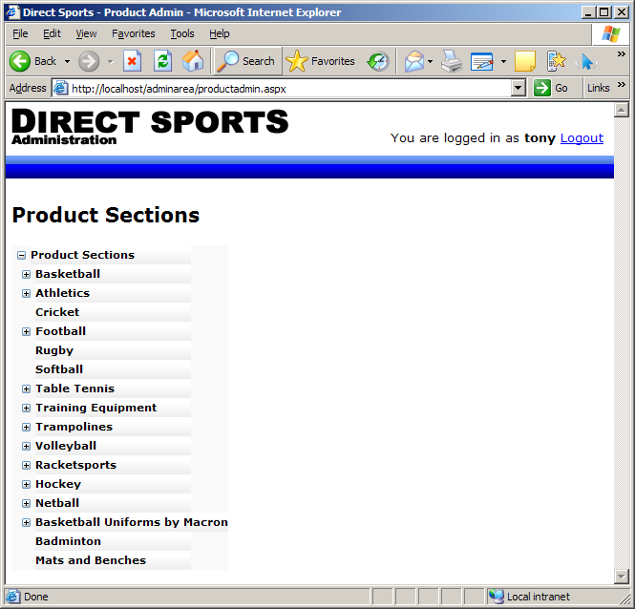

- To display products listed in each section, expand the sections on the left and click on the section that contains the product you wish to edit. An example is shown below.

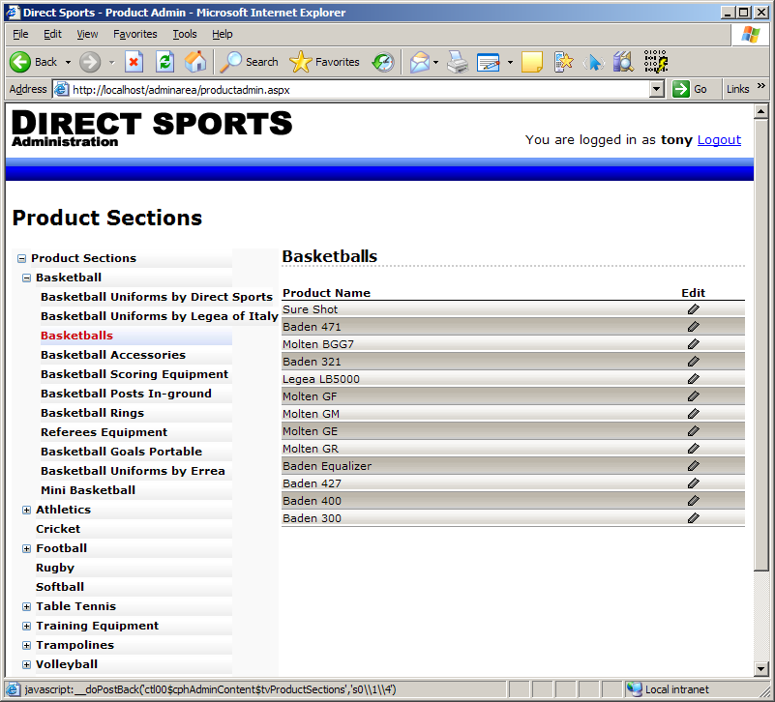

- To edit product details, click the “Edit” icon on the same grid row as the product you wish to edit. The pop-up screen below will appear.

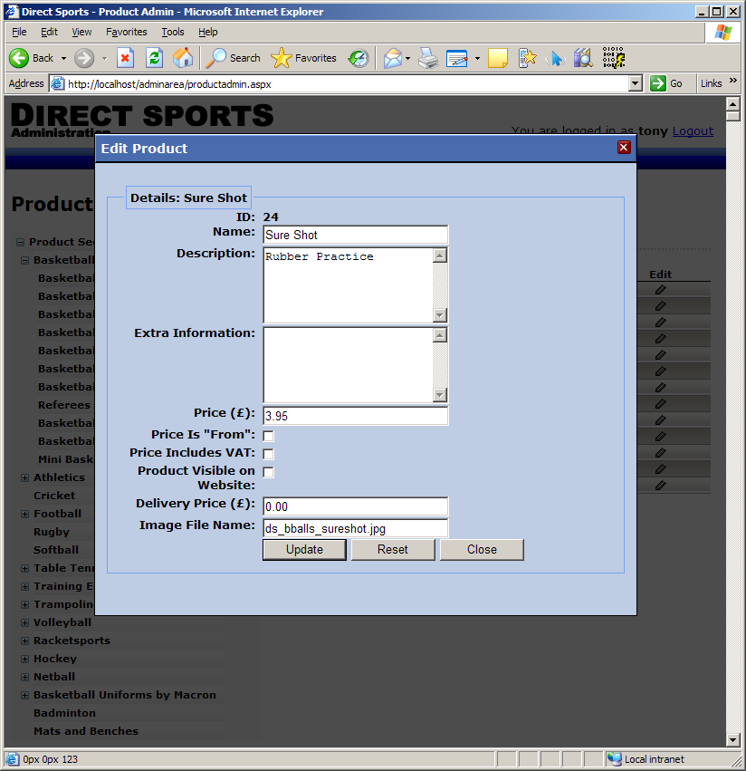

- From here you should be able to update the product details and click “Update”. The information you entered will immediately be reflected on the website.

NOTE: Products that have multiple prices under one image on the website (e.g. The “League” kit under the Direct Sports Basketball kit page) can not have their price information/description updated in the described manner. For these cases please email me the product “ID” (above the “Product Name” in the above screenshot) along with new prices and I can update these manually for you. The reason for this is that the feature is relatively new and I haven’t updated the admin screens yet. If this becomes a pain for you let me know and I can update them.

Is this the kind of guide you were looking for? If anything isn’t clear (or doesn’t work as you expect) just give me a call or email me and we can sort it out.

